Topic: Wastewater Reuse in Agriculture

Research Questions:

* (Causal) Do state regulations for quantity of material in reused wastewater result in less of the regulated material in the water?
* (Causal) What is the impact of state wastewater reuse regulation on water quality?
* (Descriptive) Do unregulated states have worse water quality than regulated states?

Data:

* List of all wastewater regulations by state from the EPA
  + Includes acceptable applications for wastewater reuse
  + Includes which materials are restricted and allowed max concentrations.
  + Includes relevant state statute, so it can be further linked

<https://www.epa.gov/waterreuse/reusing-water-agricultural-activities-resources>

* National Water Monitoring Water Council
  + Provides all the data for various monitoring sites in the US
  + Results of any lab work done on the sample including pollutant type detected and levels of said pollutant
  + Includes state that the sample was collected in.
  + Includes information on the data-collecting organization

<https://www.waterqualitydata.us/#advanced=true>

Motivation:

Droughts, and the corresponding water scarcity, are the third-largest source of billion-dollar weather disasters in the United States. Annually, they account for $6 billion dollars of costs to agriculture and agricultural labor (National, 2024). However, agricultural wastewater reuse is noted as a “significant and reliable” source of irrigation water, despite its potential to pose a hazard to both human and environmental health. Even when treated, reused wastewater has elevated levels of both inorganic and organic waste elements (Yalin et al., 2023). Our research aims to identify the magnitude of these hazards to environmental health by analyzing the effects of agricultural wastewater reuse regulations on corresponding water quality metrics.

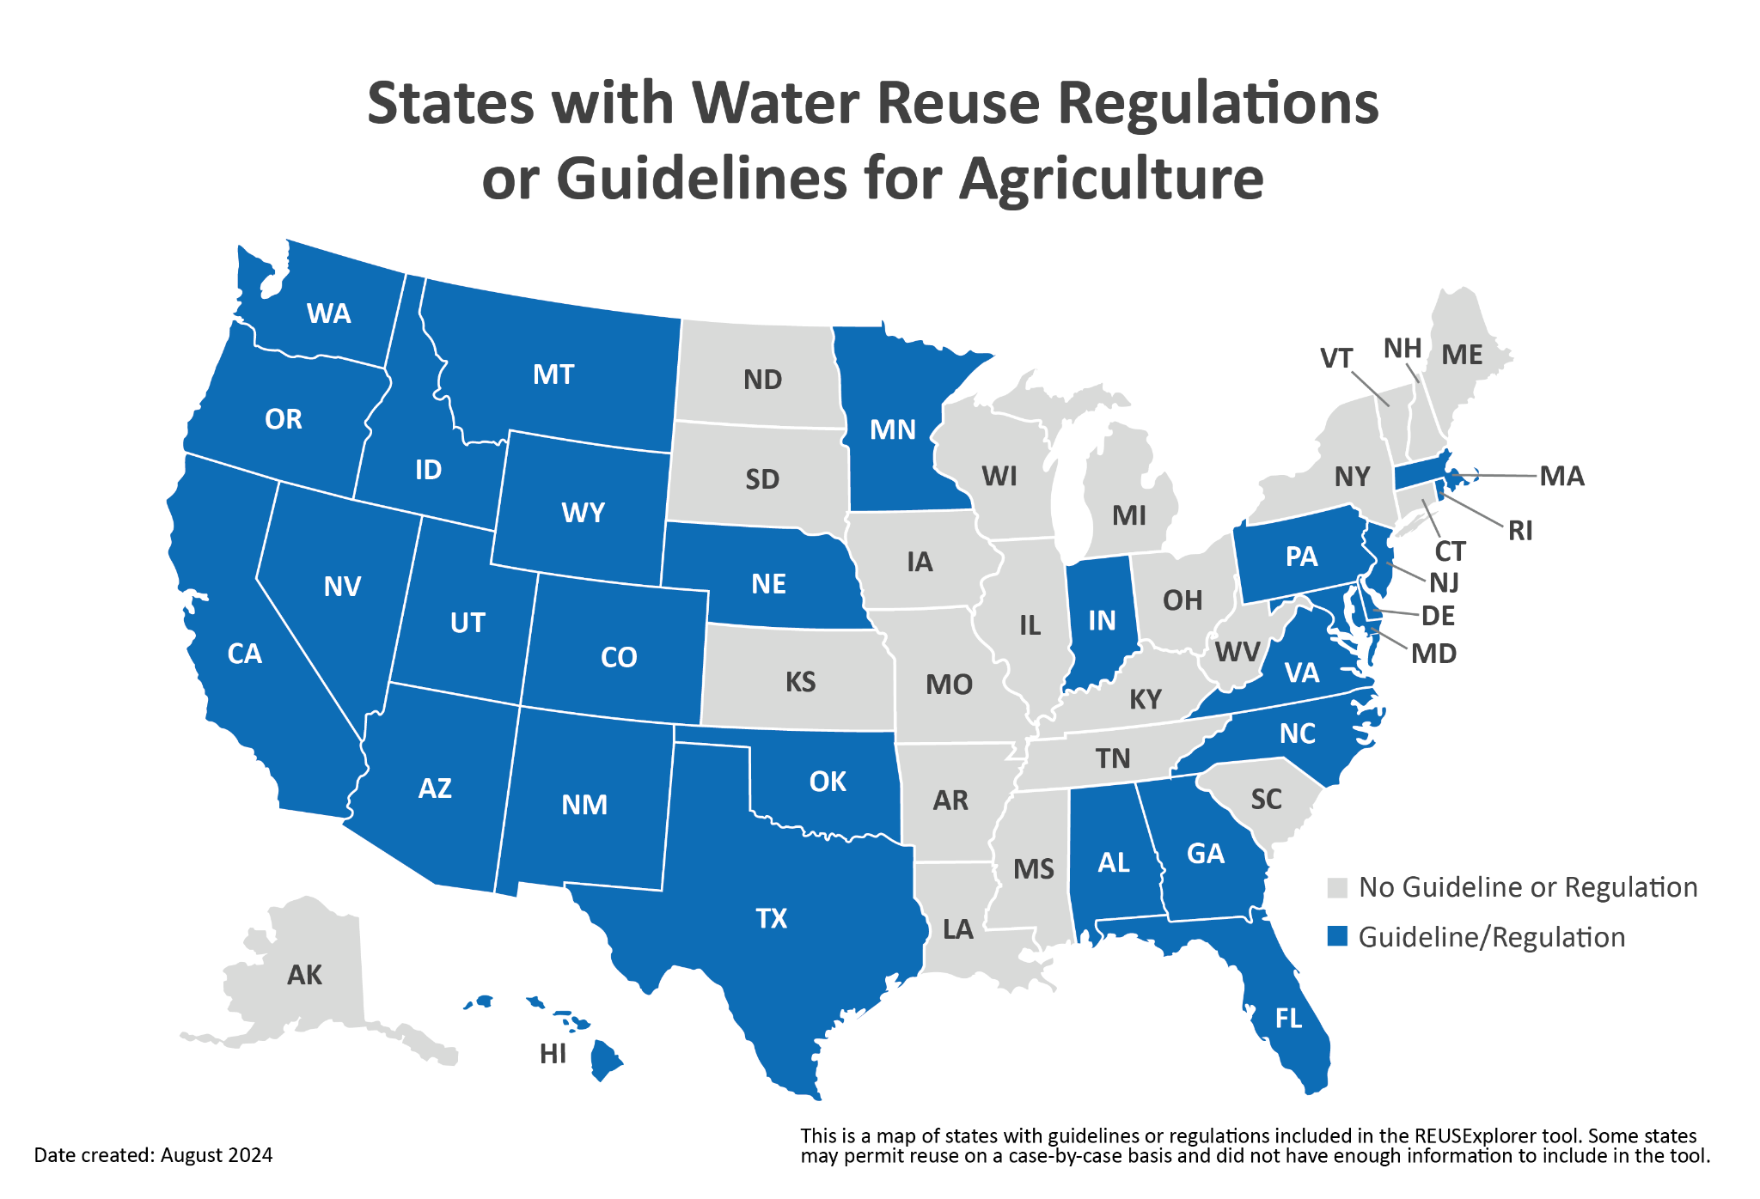

*Figure 1:*

*From:* [*https://www.epa.gov/waterreuse/maps-states-water-reuse-regulations-or-guidelines*](https://www.epa.gov/waterreuse/maps-states-water-reuse-regulations-or-guidelines)

Works Cited

National Integrated Drought Information System. (2024). *Agriculture*. Drought.gov. https://www.drought.gov/sectors/agriculture#:~:text=The%20depletion%20of%20water%20availability,forage%20irrigation%20and%20watering%20livestock.

Yalin, D., Craddock, H. A., Assouline, S., Ben Mordechay, E., Ben-Gal, A., Bernstein, N., Chaudhry, R. M., Chefetz, B., Fatta-Kassinos, D., Gawlik, B. M., Hamilton, K. A., Khalifa, L., Kisekka, I., Klapp, I., Korach-Rechtman, H., Kurtzman, D., Levy, G. J., Maffettone, R., Malato, S., … Cytryn, E. (2023). Mitigating risks and maximizing sustainability of treated wastewater reuse for irrigation. *Water Research X*, *21*. https://doi.org/10.1016/j.wroa.2023.100203